ETLV6_Wind_turbine_XX_50mn

ETLV6vid1 - DECONSTRUCTED - PART ONE

1/ Watch the first part of the video twice (“Deconstructed - part one.avi”). Fill in the blanks
while and after listening. (one blank = one word)

Wind turbine blades are designed to catch the maximum of
to make them rotate. Inside the turbine, an transforms that
into electricity that is in a _______. The stronger the wind, the faster the blades rotate, the more power generated. Getting the blades moving is the first

step and to do that, of course, requires a .

The blades are aerodynamic to fully exploit . One surface is

rounded, the other relatively flat. Wind flowing over the speeds up and creates a pocket that sucks the blades sideways, what's known as _________. Now that lift sets the blades in , let's see how this rotation can be turned into wattage to power the fridge or stove.

2/ Why are blades made in carbon fiber? List its advantages!

ETLV6vid2 - DECONSTRUCTED - PART TWO

1/ Watch the second part of the video twice (“Deconstructed - part two.avi”). Fill in the blanks
while and after listening. (one blank = one word

When the blades turn they __ a __ connected to a __ inside a generator. __ small __ fixed round the rotor turn inside the __ made of coils of __ __. These magnets are an __ neodymium __ and boron. They are small but __ magnets on Earth. In fact, they are among the __ powerful The turbine needs their incredible __ to turn the blades’ rotational energy into electricity.
When the magnets rotate inside the stator, they create a moving __ and the laws of __ dictate what follows: __ in the copper __ also start moving.

Find the answers to the following questions (you might use the Internet)

2/ What’s the function of the shaft?

3/ Explain how a generator creates alternating current?
4/ At home, where can you find alternating current?

ETLV6vid3 - DECONSTRUCTED - PART THREE

1/ Watch the third part of the video twice (“Deconstructed - part three.avi”). Fill in the blanks
while and after listening. (one blank = one word)

__ __ is easy to produce and __ but impossible to __ in a __________ . It needs to be transformed into a __ __ In order to be contained. This _ __ inside the turbine does the job. With winds of ________ miles __ __ this particular turbine can produce ___ __ watts of power, enough to light up 4 100-watt light bulbs. It doesn’t seem like much, but the wattage can be __________ by accumulating and ______________ the energy in the battery.
FINAL TASK: You must be able to explain how a wind turbine works (using schematics), specify the role of each component.
STRUCTURAL DIAGRAM

1/ Look at the flash document named "How wind power works". From what you can see and
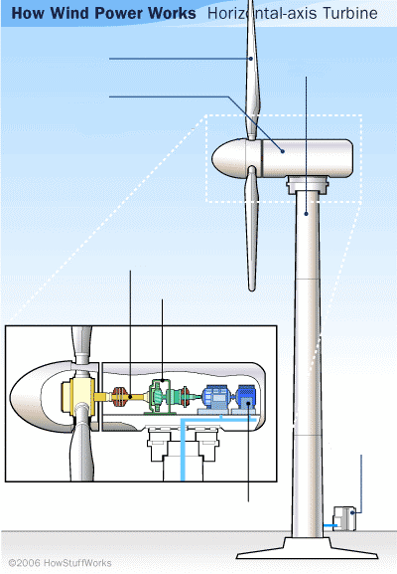

understand, fill in the structural diagram below.

