OBS2ws_What Is Planned Obsolescence
§1 : Planned obsolescence is when a product is deliberately designed to have a specific life span. This is usually a shortened life span. The product is designed to last long enough to develop a customer’s lasting need. The product is also designed to convince the customer that the product is a quality product, even though it eventually needs replacing. In this way, when the product fails, the customer will want to buy another, up to date version.
§2 : Take for example a washing machine. Planned obsolescence means that the washing machine (seen opposite) is designed to last about two years, before it breaks down outside the guarantee time. Most of the components / parts have been manufactured from quality materials with the exception of some vital parts. Two years after purchase, the washing machine will only need minor inexpensive repairs. However, between 4 to 5 years the vitals parts begin to wear out and a replacement machine is required.
For planned obsolescence to work, the customer must feel that he/she has had value for money. Furthermore, he/she must have enough confidence in the manufacturer/company, to replace the original washing machine with the modern equivalent machine, from the same manufacturer.

§3 : Planned obsolescence is sometimes designed into a product, in order to encourage the customer to buy the next upgrade. A good example of this is a mobile phone. Mobile phones are often designed with only current technology in mind, despite the manufacturers knowledge of future technological developments. For instance, a mobile phone may have USB / connections / jack plugs, that fit current products, such as headphones and computers. This means that the phone is not future proof. The manufacturer may already be working on updated phones, that connect using different sizes of USB ports / connections. Although the current phone can be upgraded with software, eventually the ‘old’ USB / connections / jack plugs will make the product obsolete. The customer will need a new phone, even though there may be nothing wrong with his / her existing phone. The old phone becomes obsolete. | 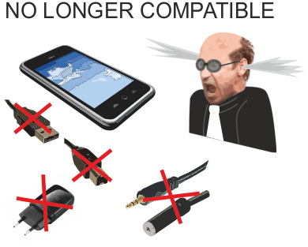

§4 : Designers following the philosophy of ‘Built In Obsolescence’, ask themselves, ‘how can a product be designed so that it breaks down quite quickly, but it still leaves customer confidence in the product and manufacturer intact’.
§5 : Planned obsolescence can be regarded as bad for the environment, because it leads to products being ‘dumped’ by customers, so that new updated products can be acquired. The quandary that good designers face, is to design desirable products, with components / parts that can be recycle or reused, when the product is thrown away, by fashion/style conscious consumers.

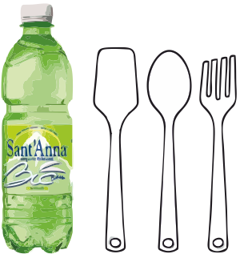 | §6 : Planned obsolescence is sometimes deliberately and openly built into products for safety reasons. Sell-by dates and use-by dates on foods, are a guide to both the retailer and customer, highlighting when a food product is safe to eat and at its best.  Further examples are disposable cutlery and soft drinks bottles, which are manufactured cheaply and designed to be used once / twice. These products are sometimes manufactured from biodegradable polylactide (PLA), which can be thrown away and yet is safe for the environment.

COMPREHENSION EXERCISES
1. True / False / Justify
Read the statements. Decide if they are True (T), False (F), or Not Given (NG).
Justify your answer with a quote or paraphrase from the text.
- Planned obsolescence always makes a product break down within a few months.
- A product with planned obsolescence must seem reliable to the customer at first.
- Washing machines are designed with all components made from low-quality materials.
- Consumers need to trust the manufacturer for planned obsolescence to work.
- Planned obsolescence only concerns electronic products.
- Some products are intentionally short-lived for safety reasons.
- Mobile phones become obsolete mainly because they cannot be upgraded with new software.
2. Short-Answer Questions
Answer in one or two sentences.
- Why do manufacturers design products to last “long enough” but not too long?
- What happens to washing machines between 4 and 5 years of use?
- Why are mobile phones not considered “future-proof” according to the text?
- What is the challenge designers face regarding the environment and planned obsolescence?
- Why can planned obsolescence be justified in the case of food products?
VOCABULARY EXERCISES (x2)
3. Match the Terms with Their Definitions
Match each word to its correct definition.
Words:
A. life span
B. vital parts
C. obsolete
D. biodegradable
E. value for money
F. future-proof

Definitions:
- No longer useful or compatible with new technology
- Designed to remain functional even as technology evolves
- Essential components necessary for a product to work
- Worth the price paid when considering usefulness and durability
- The expected duration of a product’s functioning
- Able to decompose naturally without harming the environment

4. Vocabulary in Context — Fill in the Blanks
Use the following words from the text to complete the sentences:
deliberately – guarantee – components – upgrade – manufacturer – dispose of
- The company __________ designed the device to fail after a certain number of cycles.
- After the __________ period ended, the laptop started having serious issues.
- Most __________ of the appliance were high quality, except for a few key ones.
- Customers often __________ their old devices even when they still work.
- The __________ encourages users to buy the next model every two years.
- You can still __________ the software, but the hardware will eventually be incompatible.

TASK: Sum up each paragraph in FRENCH (one sentence, max 2, per paragraph)

