BS27_Business growth
Business expansion has potential benefits and drawbacks. Some owners are reluctant to take the risk of growing the business and opt to stay small.

Benefits of a growing business
As a business grows it gains two major advantages over its smaller rivals. Large firms have more influence over market price. They're big enough to be price setters.
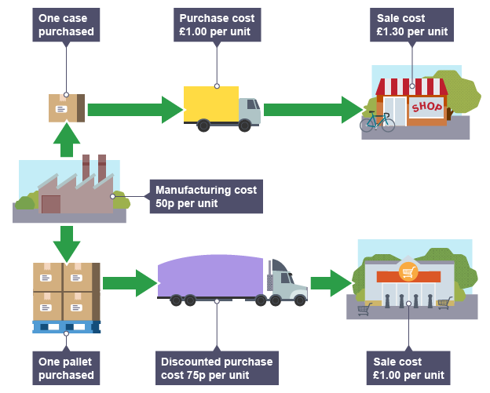
Large firms also often enjoy economies of scale. This means that a business has lower unit costs because of its large size. They can buy raw materials cheaply in bulk and also spread the high cost of marketing campaigns and overheads across larger sales.
For example, if a large firm can produce a given type of sunglasses for £20 while it costs its smaller rival an average of £30, then the larger firm has a £10 per unit cost advantage. Larger firms can charge lower prices or enjoy a higher profit margin.
Economies of scale are a major source of competitive advantage for large firms.

Methods of expansion
A business can grow in size through:
- Internal (organic) growth - the business grows by hiring more staff and equipment to increase its output.
- External growth - where a business merges with or takes over another organisation. Combining two firms increases the scale of operation.
- Franchising - where a business leases its idea to franchisees. This allows new branches to open across the country and internationally

Profits or growth?
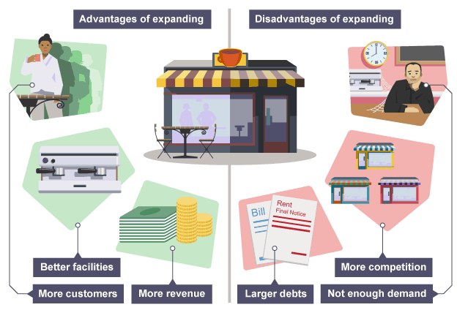
Owners can face a dilemma in deciding whether to expand. Expansion is risky. There's always the chance that any expansion plans can fail and result in losses rather than profit. Owners are then worse off than before the growth of the business.
The risk of expansion means that some owners are reluctant to chance funds. They opt instead to stay small and earn a relatively risk-free profit.
There is potentially a major drawback to avoiding growth. Small businesses can be at a cost disadvantage compared to their larger rivals enjoying economies of scale. As small firms cannot compete with the low prices set by their larger rivals, they have to compete on service or quality.

Exercise 1 – Translate into English (French → English)
Traduisez les expressions ou phrases suivantes en anglais. Les mots/expressions se trouvent dans le document.
- Une entreprise qui choisit de rester petite
- Avoir plus d’influence sur le prix du marché
- Économies d’échelle
- Répartir les frais généraux
- Avoir un avantage concurrentiel
- La croissance interne (ou organique)
- Une fusion ou une acquisition
- Louer son concept à des franchisés
- Une marge bénéficiaire plus élevée
- Une entreprise qui fait face à un dilemme

Exercise 2 – Gap-fill with Business Vocabulary
Complétez les phrases suivantes avec un mot ou groupe de mots approprié(s) du document (vous pouvez changer la forme si nécessaire).
Spread – franchising – service - internal (organic) - price setter – cost - economies of scale. - risk-free - external
- When a business grows large enough, it can become a __________ rather than a price taker.
- Buying raw materials in bulk allows large firms to benefit from __________.
- A firm that merges with another company is experiencing __________ growth.
- Small firms that cannot compete on price must instead compete on __________ or quality.
- Leasing a company’s idea to independent operators is called __________.
- High marketing and overhead costs can be __________ across a larger volume of sales.
- The possibility of failing and losing money makes business __________ a risky decision.
- Some owners prefer to stay small and earn a relatively __________ profit.
- Producing at a lower unit cost gives big firms a significant __________ advantage.
- Hiring more staff and buying more equipment is an example of __________ growth.

