TM62_AUSTRALIA_facts

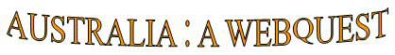 | 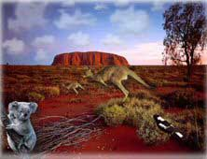

1. 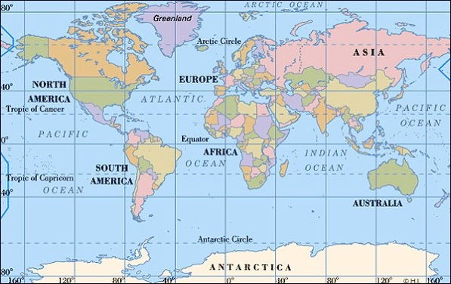

- Which hemisphere is Australia in? …………………………………………………………………….
- So, when it’s winter in France, it’s ………………………………………… in Australia.
2. 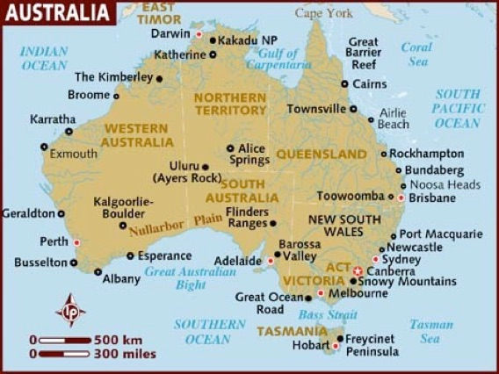

- Australia is composed of ………………… states and …………………. territories.
- What is the capital city of Australia ? ………………………………….………………………………
- Which are the largest cities?……………………………………….……………………………………
…………………………………………………………………………..……………………………………
- How many people are there in Australia ? …………………………………………………………..……………………………………………………
- What is the nickname of Australia ? Why ?
…………………………………………………………………………..…………………………………….

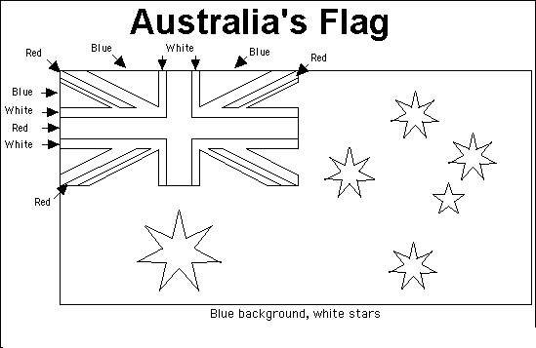

- Why is there the British flag on the upper left corner ?
………………………………………………………….………………………………………………………
4. What is the currency in Australia ?
In France, we pay in euros ; In Australia, they pay in ……………………………………………………..
5. Government in Australia.
- Who is the « Head of State » of Australia ? ………………………………………………………………………………………………………….
- Who represents them when they are not here ? …………………………………………………………………………………………..……………..
- Who is the Head of the Government ? …………………………………………………..
6. The Aborigines.
- Who are they ? ……………………………………………………………………………………………………
- Look at the Aboriginal flag : 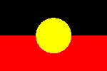
The black represents ………………………………………………………………………………………………..
The red represents ………………………………………………………………………………………………….
The yellow represents ………………………………………………………………………………………………
- What’s a « didgeridoo » ? ………………………………………………………………………………………….
- What was a boomerang used for ? ………………………………………………………………………………
7. Ayers Rock.
- What’s the Aboriginal name of it ? ……………………………………………………………………
- Why is it so important for the Aborigines ? ……………………………………………………………
……………………………………………………………………………………………………………………
- What is the « outback » ?

8. The Flying doctors.
- Who are they ? What do they do ?.
9. Alice Spring School of the Air.
- What is it ? ………………………………………………………………………………………………………….
…………………………………………………………………………………………………………………………..
10. The animals.
- Write the names of these Australian animals

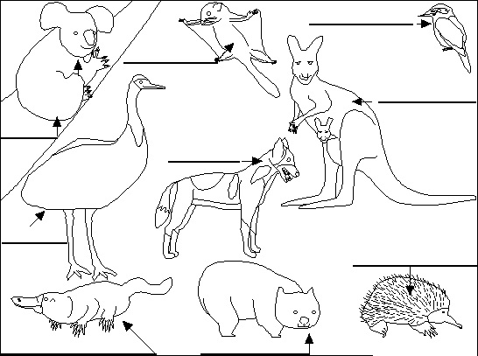
  Dingo
  Emu
  Duck-billed platypus
  Echidna
  Koala
  Kangaroo
  Kookaburra
  Sugar glider
  Wombat -
13. Sport.
The Australians are very sporty. What sports do they practise ?

