ETLV101bis_KEY_car_com_DSCR

Dedicated short-range communications
Dedicated short-range communications are one-way or two-way short- to medium-range wireless communication channels specifically designed for automotive use and a corresponding set of protocols and standards .In October 1999, the United States Federal Communications Commission (FCC) allocated in the USA 75MHz of spectrum in the 5.9GHz band for DSRC to be used by Intelligent Transportation Systems ITS . Also, in Europe in August 2008 the European Telecommunications Standards Institute (ETSI) has allocated 30 MHz of spectrum in the 5.9GHz band for ITS.
Currently its main use in Europe and Japan is in electronic toll collection. DSRC systems in Europe, Japan and U.S. are not, at present, compatible.
Other possible applications are:
- Emergency warning system for vehicles système d'alerte en situation d'urgence (EWS).
- Adaptive Cruise Control régulation adaptative de la vitesse (RAV) [...]
- Cooperative Forward Collision Warning Les systèmes d'alerte anti-collision avant
- Intersection collision avoidance systèmes d'évitement des collisions en intersection
- Approaching emergency vehicle warning avertissement d’un véhicule d'urgence qui s'approche
- Vehicle safety inspection inspection de sécurité des véhicules
- Transit or emergency vehicle signal priority feux prioritaires pour véhicules d’urgence ou de transport en commun
- Electronic parking payments Paiement électronique du stationnement
- Commercial vehicle clearance vérification (dédouanement) des véhicules commerciaux
- In-vehicle signing système de signalisation à bord des véhicules
- Probe data collection collecte de données au moyen de capteurs
- Highway-rail intersection warning avertissement intersections route-voie ferrée
- Electronic toll collection perception par télépéage
Other short range wireless protocols are IEEE 802.11, Bluetooth and CALM.

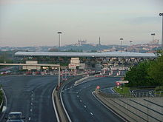

What is Vehicle-to-Vehicle (V2V) Communication All About?
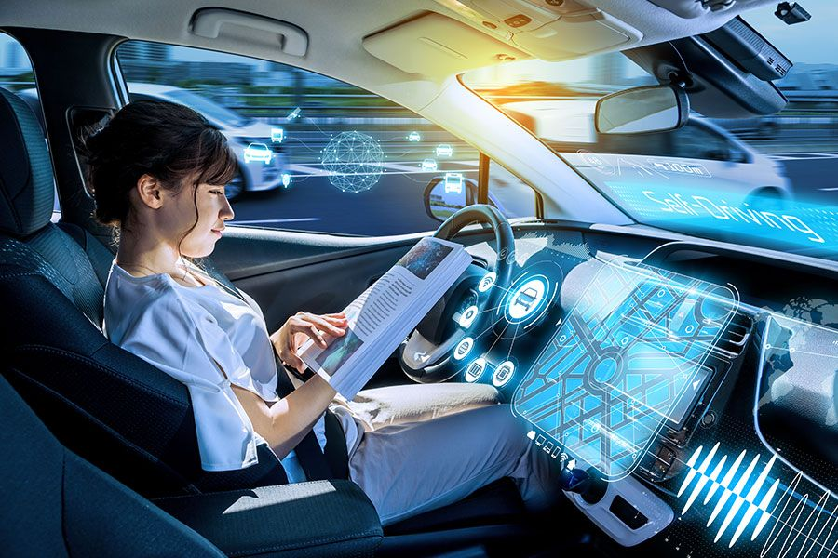
What is vehicle-to-vehicle communication? Right now, it’s limited to drivers flashing high beams (“cop ahead”), flicking on a turn signal (“might turn, might change my mind”) or throwing up a middle finger (infinite meanings). But in the very near future, vehicles will be in constant communication with each other without drivers being involved at all. This will even further expedite the capabilities and intelligence of our quickly-growing autonomous vehicle technologies.
How does V2V communication work?
Vehicle-to-vehicle (V2V) communication works with DSRC (Dedicated Short Range Communications), which is a type of Wi-Fi that sends brief messages up to 10 times a second over short distances, about 1,000 feet. On a busy highway, vehicles might send automated messages to each other communicating things like “Road is slippery,” or “Ambulance coming!” or “Traveling 63 mph, road clear.”
This technology already exists. In Japan, certain Toyota models have V2V communication built in that conveys a few simple data points: location, speed, and heading. Soon, it’ll be widespread in the United States, too, as new cars and light trucks may be required to include V2V technology by 2023. Navigant Research predicts “that by 2025, more than 20 million vehicles will be sold annually with DSRC-based V2V in North America and nearly 70 million globally.”
The technology might already be outdated, however. While carmakers work to install DSRC capabilities in new cars, others are asking, “Why can’t we just use our phones?” An app called Nexar has a V2V communication function that sends traffic alerts to other, nearby phones running the app.
The pros of V2V communication
It could prevent crashes. The vast majority of car crashes are caused by human error. The U.S. Department of Transportation says car-to-car communication can help, as it has the potential “to significantly reduce many of the most deadly types of crashes through real time advisories alerting drivers to imminent hazards.”
It could ease traffic congestion. Imagine if all the individual data points from millions of cars were sent to a central hub. With so much real-time traffic data, transportation managers could adjust traffic light timing and redirect traffic to make rush hour flow more smoothly. Not only that, but each individual car could use the technology to maintain a consistent following distance. Imagine law abiding, organized highways, instead of hundreds of drivers jockeying for position, changing in and out of lanes.
It could improve fuel efficiency. A fleet of trucks equipped with vehicle-to-vehicle technology can do something called platooning: driving in close formation, like a flock of geese, to reduce drag and save gas. Platooning results in fuel consumption savings of up to 5 percent for the lead truck and up to 10 percent for the trucks following in formation, tests have found.
The drawbacks of V2V communication
Drivers should be concerned about their privacy. V2V data can reveal all kinds of things about you: where you’re going and when, as well as your driving habits. Who has access to this data? And how might they use it? “We have learned the hard way that both the government and private companies will go to great lengths to track vehicles—just look at the proliferation of Automated License Plate Readers (ALPR),” the Electronic Frontier Foundation warns.
Liability could get complicated. Imagine you’re zipping along the highway and your car, using V2V communication, tells you the road ahead is perfectly clear. Then — screeeech! — you smash into the back of a truck stuck in a traffic jam. Is the crash your fault? Or is the malfunctioning V2V tech to blame?
Hacking could cause chaos.The proliferation of V2V communication, whether in human-piloted or driverless cars, gives malicious hackers a new opportunity. DSRC-enabled cars are vulnerable to at least six types of attacks, one security firm warns.
Until car-to-car communication becomes a reality for everyone, the best thing you can do to protect yourself is make sure you carry dependable car insurance.

Now write a summary of the article (60 words). It will be easier if you answer the following questions and follow the structure of the text (try not to consult the text again!)

1. What is vehicle-to-vehicle communication?
2. How does V2V communication work?
3. The pros of V2V communication
4. The drawbacks of V2V communication

VIDEO:

How Vehicle-to-Vehicle Communication Works & Why It’s Important
In a world where cars are becoming smarter and more connected, Vehicle to Vertical Communication or V2V is taking the driving experience to the next level. But how exactly does this technology work and what impact does it have on our safety and the future of driving? V2V communication refers to a system where vehicles can exchange information with one another wirelessly in real time. This exchange of data includes information about the vehicle's speed, position, direction, braking status and even road conditions.
The technology relies on a short-range high-speed wireless communication system that ensures vehicles can talk to each other over distances of several hundred meters, allowing them to instantly exchange critical data that can help prevent accidents and improve traffic flow. V2V systems use two key technologies, dedicated short-range communication and cellular V2X. These technologies enable vehicles to send out signals about their location, speed and movements.
When a vehicle is on the road, it constantly sends out a message about its speed, direction and location. Nearby vehicles equipped with V2V technology can receive this data almost instantly. If a car suddenly brakes hard or takes a sharp turn, other vehicles can immediately receive a warning, allowing the driver to take action and avoid a potential collision.
Now, let's talk about the real impact of V2V communication. The most obvious benefit of V2V is safety. By sharing real-time data, V2V allows vehicles to anticipate and react to potential hazards long before a human driver could, reducing accidents caused by human error, such as rear-end collisions or lane change mishaps.
In addition to collision avoidance, V2V can improve traffic flow, for instance, by allowing cars to talk to each other. We could see less stop-and-go driving, reduce congestion and smoother movement in dense traffic areas. And it's not just safety.
V2V also plays a role in fuel efficiency. By smoothing traffic flow, it reduces the need for frequent acceleration and braking, which in turn can save fuel and reduce emissions. Another exciting area where V2V communication is paving the way is autonomous driving.
Self-driving cars will rely heavily on V2V systems to communicate with one another and with road infrastructure, allowing them to coordinate movements and ensure that they operate safely within mixed traffic, including both human-driven and autonomous vehicles. In the future, V2V communication could enable things like platooning, where a group of vehicles drive in close formation, synchronizing their speeds and movements to reduce air drag and improve fuel efficiency. V2V communication doesn't just work between vehicles, it can also extend to vehicle-to-infrastructure.
With V2I, cars can communicate with traffic lights, road signs and even the cloud to get real-time updates about traffic conditions, accidents and roadwork, allowing them to plan more efficient routes. While the potential of V2V communication is huge, there are still a few challenges to overcome. One major challenge is ensuring that the technology is universally adopted.
For V2V to work effectively, it needs to be in every car on the road. That means automakers, governments and tech companies need to collaborate on creating standards for communication and ensuring that V2V are compatible across different brands and models. But despite these challenges, the future looks promising.
As V2V and V2I systems evolve, they will become integral components of smart cities, driving us closer to a future where vehicles are safer, more efficient and better connected. So, what does the future hold for V2V communication? While we may not see it in every car just yet, this technology is rapidly becoming a vital part of how we drive and interact with our roads. As we continue to push towards more autonomous and safer driving, V2V communication will undoubtedly play a central role in shaping the future of transportation.

EXERCISE ONE - 10 Questions and Answers for Grade 12 Students:

Questions
- What does the abbreviation V2V stand for?
- What kind of information do vehicles exchange through V2V communication?
- How far can V2V wireless communication typically reach?
- What are the two key technologies used in V2V systems?
- How can V2V help drivers avoid collisions?
- Besides safety, what is another benefit of V2V communication for traffic?
- How does V2V contribute to fuel efficiency?
- Why is V2V important for self-driving cars?
- What is platooning in the context of V2V?
- What is one major challenge to the universal adoption of V2V?

Answer Key
- V2V stands for Vehicle-to-Vehicle communication.
- Vehicles exchange data such as speed, position, direction, braking status, and road conditions.
- V2V communication can reach over several hundred meters.
- The two key technologies are dedicated short-range communication (DSRC) and cellular V2X.
- By sending real-time warnings, such as when a car brakes suddenly, so other drivers can react and avoid collisions.
- It can improve traffic flow by reducing congestion and stop-and-go driving.
- It reduces the need for frequent braking and acceleration, saving fuel and lowering emissions.
- Self-driving cars need V2V to coordinate with other vehicles and infrastructure to drive safely in mixed traffic.
- Platooning is when a group of vehicles drives in close formation, synchronizing speeds to reduce air drag and improve efficiency.
- A major challenge is ensuring universal adoption and compatibility across all vehicles and brands.

EXERCISE TWO - 10 Words Related to Science and Technology with Definitions and French Translations:
- Localization
  - Definition: The process of determining the exact position of an object, such as a vehicle, often with high precision.
  - French Translation: Localisation
- Bandwidth
  - Definition: The range of frequencies within a given band, used for transmitting signals, essential for communication technologies like DSRC.
  - French Translation: Bande passante
- Spectrum
  - Definition: The range of electromagnetic frequencies used for transmitting signals; DSRC operates in the 5.9 GHz band.
  - French Translation: Spectre
- Retrofitting
  - Definition: Adding new technology or features to older systems, such as installing DSRC in existing vehicles.
  - French Translation: Rétrofitage
- Proprietary
  - Definition: Relating to ownership or control of something, often implying restricted access or use, relevant to DSRC standardization issues.
  - French Translation: Propriétaire
- Aerodynamic
  - Definition: The study of how gases interact with moving bodies, relevant to DSRC's potential to reduce fuel consumption through improved vehicle spacing.
  - French Translation: Aérodynamique
- Interoperability
  - Definition: The ability of different systems or devices to work together without conflict, a key challenge for global DSRC deployment.
  - French Translation: Interopérabilité
- Traffic Signal Phase and Timing
  - Definition: The sequence and duration of traffic light changes; DSRC can communicate this information to vehicles for better traffic management.
  - French Translation: Phase et synchronisation des feux de circulation
- Automotive
  - Definition: Relating to motor vehicles; DSRC is a critical technology in the automotive industry for improving vehicle communication and safety.
  - French Translation: Automobile
- Collision Avoidance
  - Definition: A system or set of actions designed to prevent accidents, which is a primary function of DSRC technology.
  - French Translation: Évitement de collision

